Kent & East Sussex Railway
Operating Department Mutual Improvement Class
Andyh@kesr.org.uk
www.kesr-operating.co.uk
Created by: Pete Spratling
Authorised by: Andrew Hardy
Version: 3.0 Date: 03/03/2015
Diagrammatic Route Map

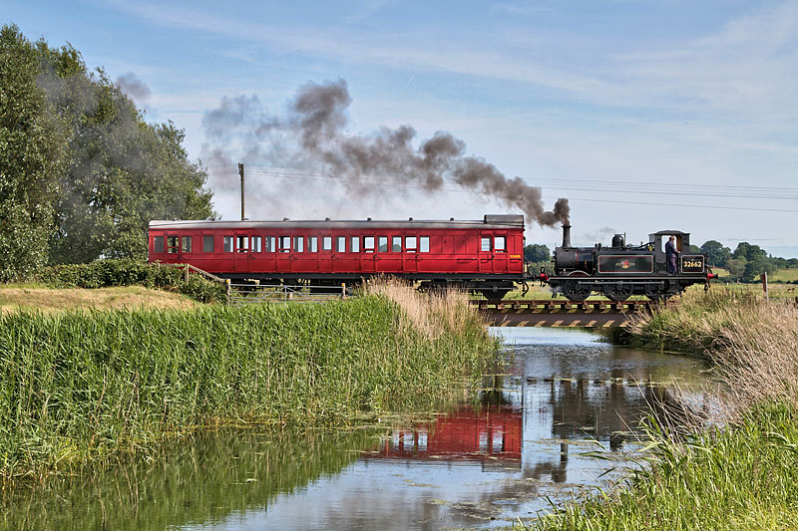

Please Note:
This route map has been produced to assist members of the operating department on KESR with route knowledge. This document is purely for information only. If their are any discrepancies between this document and any official KESR documentation then the official documentation will take preference over this guide. Only Permanent speed restrictions will be shown in this guide. This document will be updated as and when changes occur and when the information is received.

